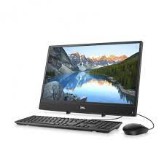

Dell Inspiron 3277

Intel@ Core I5-7200U

HD-Graphics 620

Rs.70,500